PRODUCT DETAILS

**AURA SWISS LADIES WATCH J5.643.M**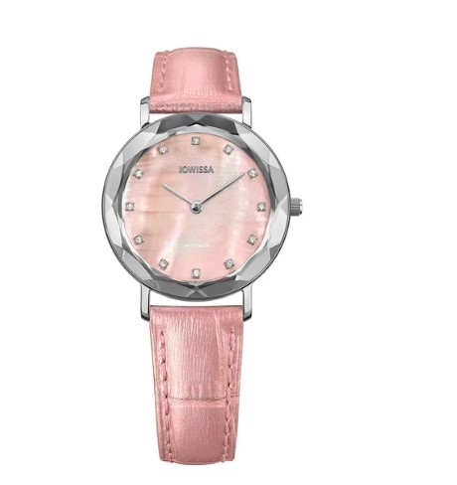

**€219.90**

**Specifications**

**Movement**: Ronda Swiss quartz movement with hours, minutes as well as long battery life span

**Dial**: Mother of Pearl

**Time** **indicator**: 12 applied rhinestones as hour indices

**Hands**: Filament

**Watch** **case**: Stainless steel

**Case** **surface**: Gloss polished

**Back** **case**: Stainless Steel back cover, easy battery replacement

**Case** **diameter**: 30.5 mm

**Case** **height**: 7 mm

**Water** **resistance**: 5 ATM (shower-proof)

**Watch** **glass**: Tempered mineral glass with diamond-cut bezel

**Bezel**: Metallized, integrated in the glass

**Strap** **material**: alligator-embossed genuine leather strap with pearled effect

**Band** **width**: 15 mm

**Buckle**: Stainless steel with laser-engraved logo

**Adjustment** **range**: Wrist circumference of 145-190 mm

**Interchangeable** **band**: Yes, with quick release

**Gender**: Female

**Swiss** **made**: Hand-assembled in Switzerland

**Color**: Steel / Rose Mother-of-Pearl

**Reference**: J5.643.M